**Semester End Practical Exam!!**

**Name:** Dhavalkumar Vijaykumar Patel

**Class:** M.Sc. Cyber Security Sem-3

**Enrollment Number:** 032200300002034

**Subject:** Cloud Security and Forensics(CTMSCS SIII EL3)

**Date:** 12 January 2024

**Question 04: Set up a private cloud using any open-source tool of your choice and launch an SQL injection attack.**

Install Next Cloud.

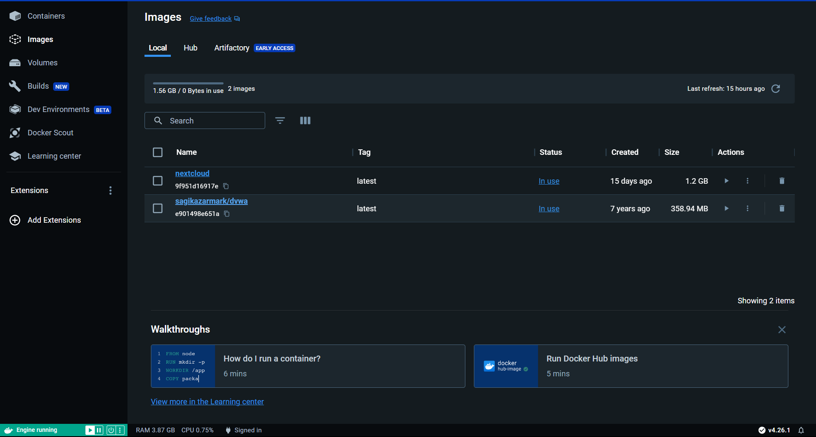

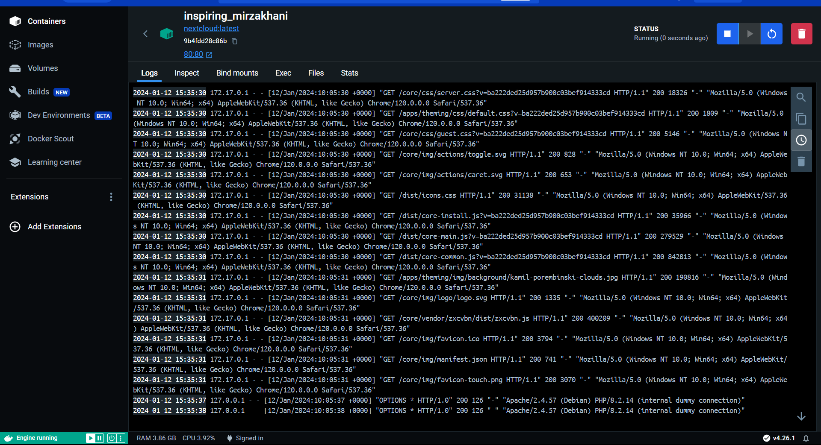

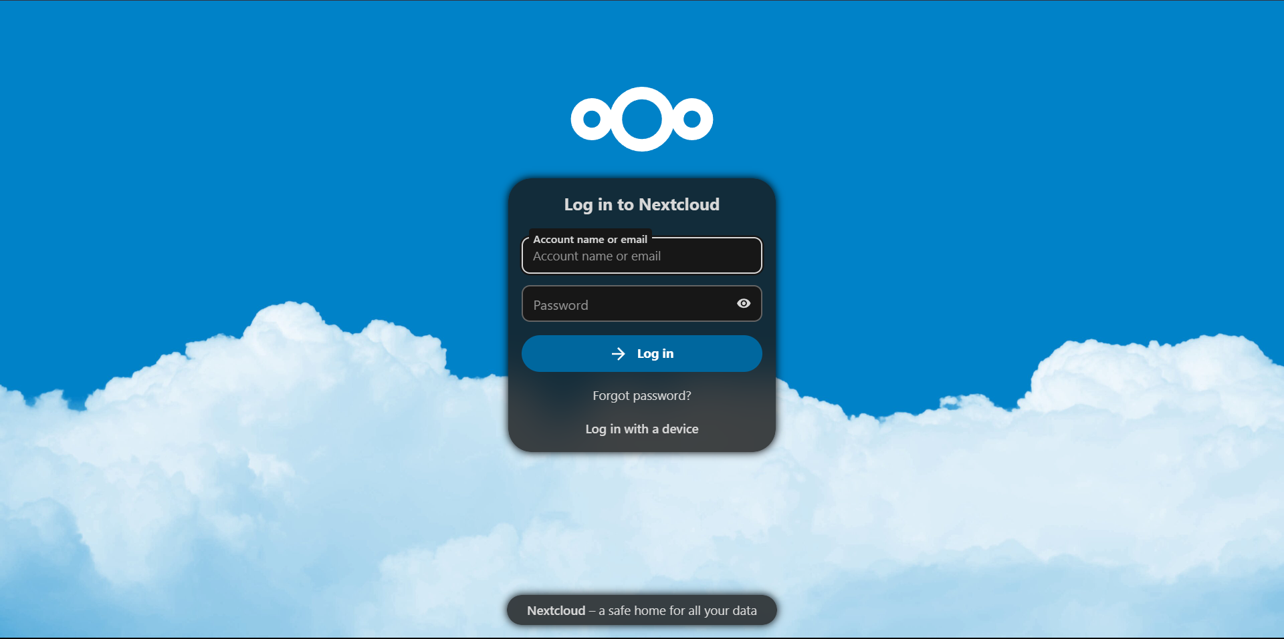

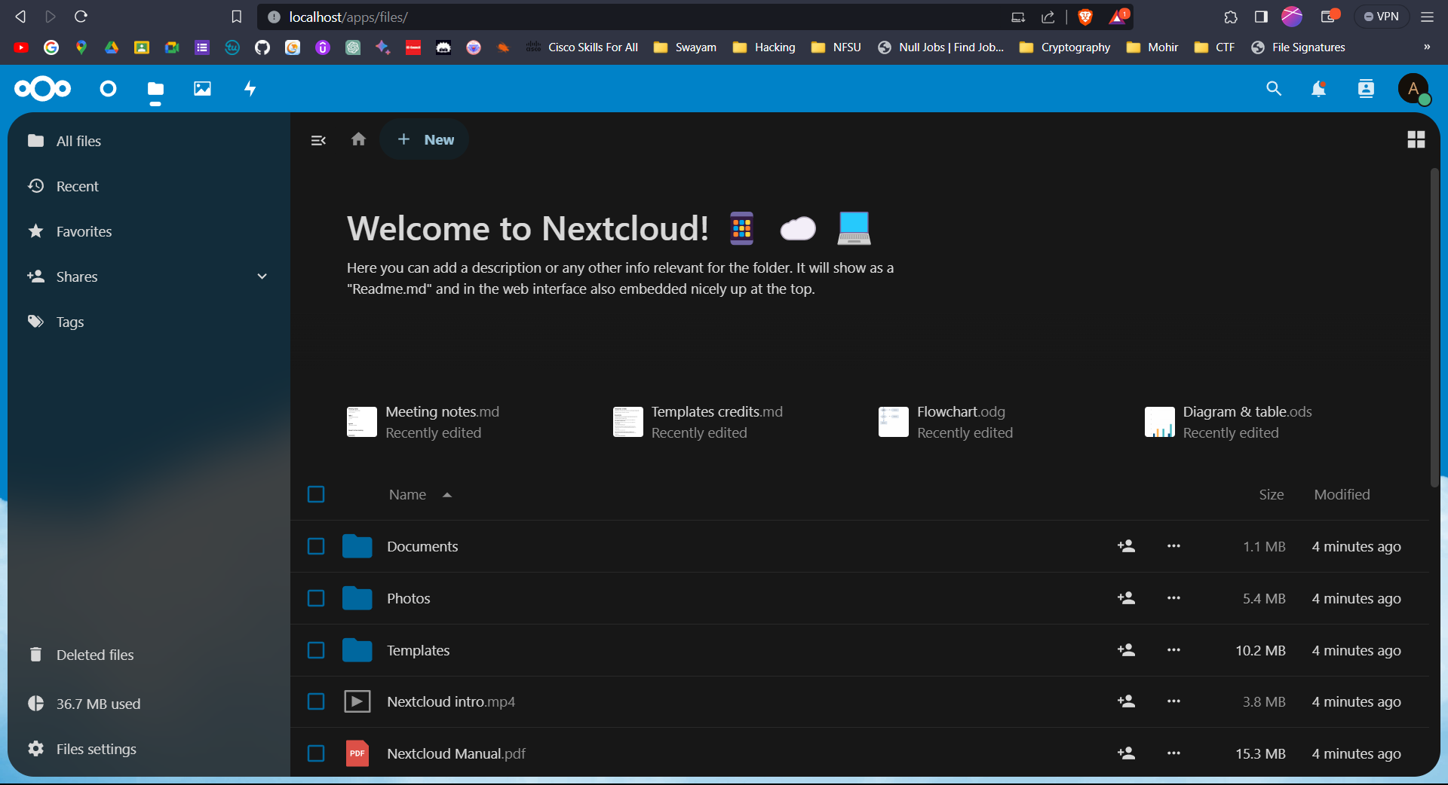

**Open Kali linux and perfrom SQL injection using SQL-Map**

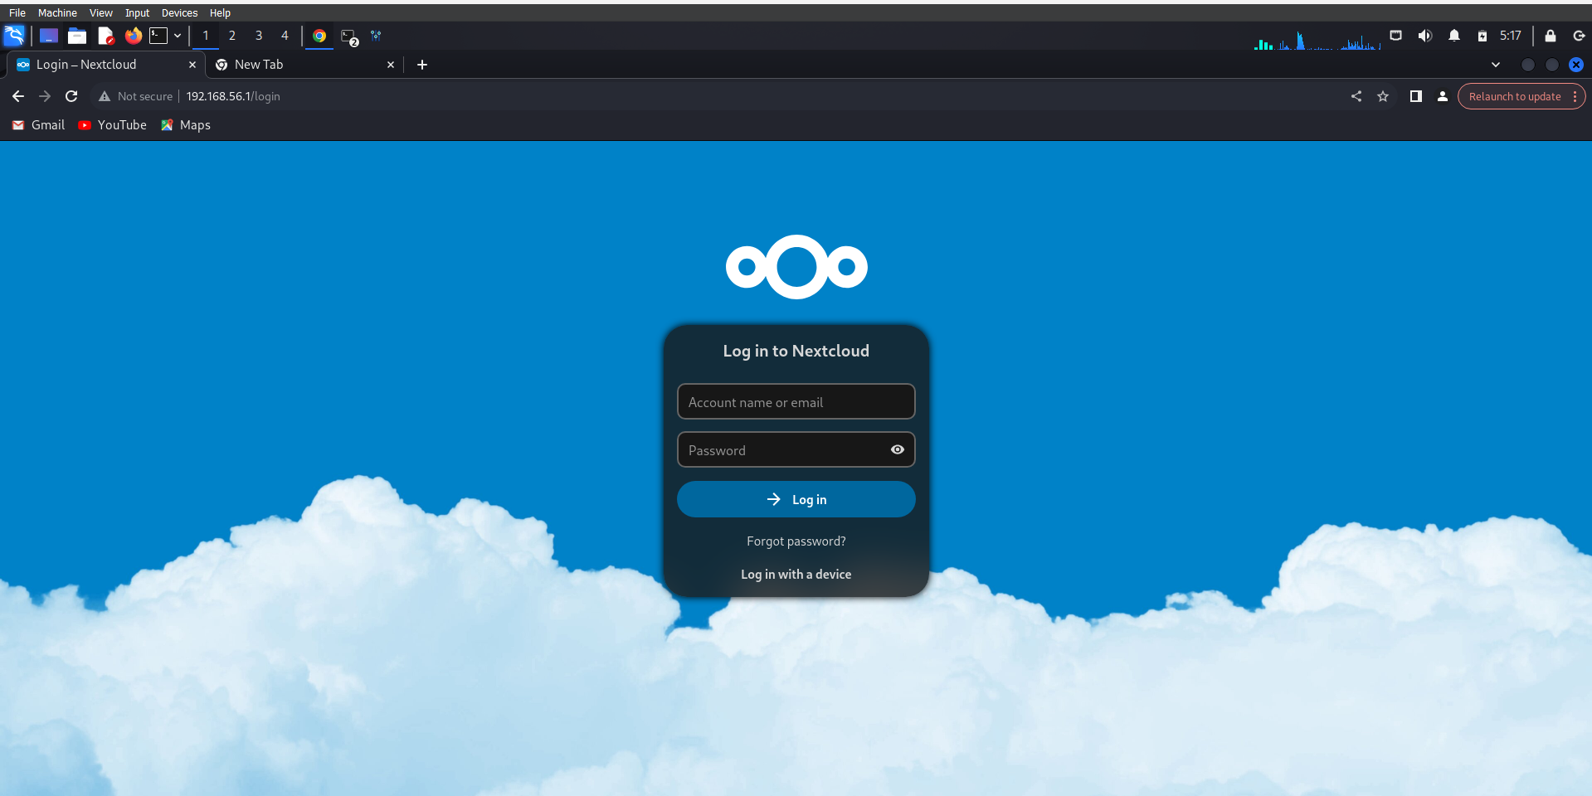

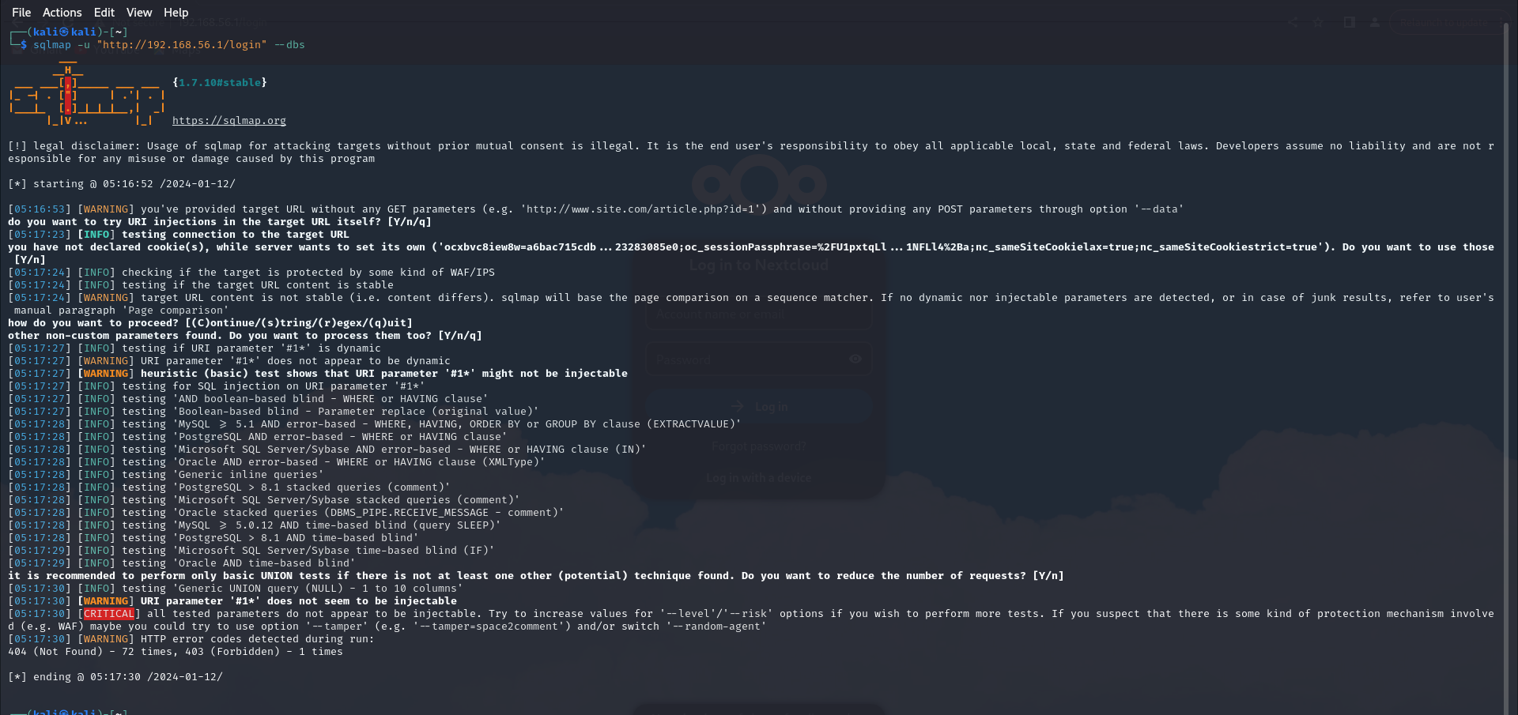

Or you can use A Docker

